

Chainsaw Team Guide

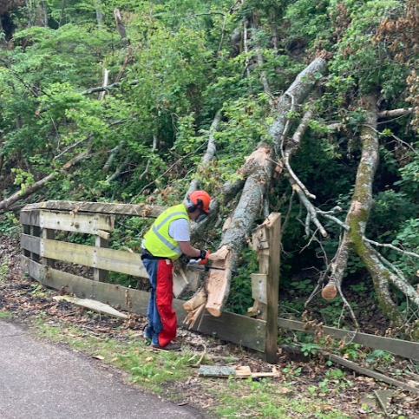

Table of Contents

Introduction |  | 1
The Little Miami State Park |  | 2
 | History | 2
 | Trail Cross section, Section Designators, Park map | 2
 | Authority, Cooperative Agreement, Right of Entry | 5
Qualification |  | 5
 | Procedures | 5
 | Criteria | 6
 | Training | 6
Activities and Responsibilities |  | 6
 | Personnel | 6
 | HotLine | 6
 | Tasks – Trail and Berm | 7
 | Vegetation Removal from Park | 7
 | Live Trees | 7
 | Maintaining Equipment | 7
 | Tool Boxes | 8
 | Service Hours | 8
Safety |  | 8
 | Personnel Protective Equipment | 8
 | Safety Procedures and General Rules | 9
 | Refueling and Limbing | 11
 | Reducing Kickback | 11
 | Volunteer Limitations | 12
 | Available Equipment and Tool Caches | 12
Emergency Information |  | 12
 | Little Miami State Park Contact Info | 13
 | Friends of Little Miami State Park Contact Info | 13
 | Public Police, Fire, EMS, Sherriffs, Township | 13
Document Authors and Version Control |  | 13

Introduction

Thank You!

Thank you for volunteering to be part of a chainsaw crew for the Little Miami State Park. You are helping to maintain our trail system, and protecting an important natural, historic and community resource in southwest Ohio. Annually, more than 1.5 million users will be positively impacted by the work you do to keep the trail clean, friendly and safe.

Little Miami State Park (LMSP) is part of the Little Miami Scenic Trail, 78 miles of former railroad right-of-way converted to a recreation trail, which stretches from the east side of Cincinnati north all the way to Springfield. In the mid-1970s, various government entities started acquiring the original abandoned rail line and converting it into the current multi-use trail. Our section, stretching from Hedges Road (mile 3.3) to Newtown (mile 53.5), is owned and maintained by Ohio Department of Natural Resources (ODNR) and this is Little Miami State Park. The section in Clark County is managed by Clark County Parks. Greene County Parks and Trails manages the section north of Hedges Road to the Clark County border. And the section south of Newtown to Lunkin airport and beyond is managed by Great Parks of Hamilton County. And the Little Miami Scenic Trail connects to over 350 miles of paved, multi-use recreational trails in Ohio’s Miami Valley region.

The right-of-way is 66-feet wide along most of its length, and the boundaries are easily discernible along much of the trail, especially in winter when the leaves are off and boundary fence remnants are visible in the vegetation along the margins. At 50 miles long, this is certainly Ohio’s skinniest state park!

The LMSP is under the jurisdiction of ODNR, Division of Parks & Watercraft (DPW). DPW’s mission is “to provide exceptional outdoor recreation and boating opportunities by balancing outstanding customer service, education, protection and conservation of Ohio’s state parks and waterways.”

Friends of the Little Miami State Park (FLMSP) is a 501(c) (3) nonprofit organization dedicated to ensure and enhance a safe and well-maintained multi- use trail as an integral part of the Little Miami River recreational corridor, while protecting and enhancing the natural environment and conserving resources. Our five Strategic Organizational Goals are: Safety, Park Condition& Drainage, Volunteer Management, Amenities/Convenience, and Beauty/Habitat Restoration.

FLMSP was founded in 2008, after three serious accidents occurred due to poor surface conditions on wooden bridges. FLMSP raised $11,000.00 to assist ODNR in paving 15 overpasses. We assist park management with development planning, routine maintenance, capital improvements, safety concerns, parking issues and promotions. The organization as of 2024 has over 100 active volunteers.

THE LITTLE MIAMI STATE PARK
History
The creation of LMSP introduced a new concept to the Ohio state park system – a trail corridor. This new concept focuses on offering numerous recreational pursuits – bicycling, hiking, cross-country skiing, rollerblading, backpacking and horseback riding. The LMSP corridor also provides access for canoeing the Little Miami River. Established as a state park in 1979, LMSP runs through four counties and is approximately 50 miles in length.

The majority of the Little Miami Scenic Trail (LMST) is built on an old railroad bed---a rails-to-trails conversion project. The Little Miami Railroad was built in 1845 and ran from Xenia to Cincinnati. The history of the Little Miami Railroad can be found on the FLMSP website at http://littlemiamistatepark.org/history/the- little-miami-scenic-trail.

While each segment is unique, the LMSP’s 66’ right-of-way is adjacent to private, public, utilities, or ODNR owned properties. The asphalt is typically in the center of the right-of-way, but not always. A cross section of the right-of-way is shown below figure A-1. Within the right-of-way is a 9’ wide blacktop surface, a grass berm on each side of the pavement, drainage on each side of the rail bed, culverts of various sizes to move water under the rail bed, and usually some boundary fencing on each side of the property (See Fig. A-1). In some sections of the trail, the “poles” that carried the original railroad signal wires are visible and are slowly rotting away.

Wood fences separate the blacktop trail from the deeper culverts and ravines to protect the trail users from falls. Bridges across larger streams were created from the original railroad bridges by adding wood planks as bridge decking. The decks proved to be dangerously slick in wet conditions and the wood planks were covered with a layer of blacktop by the FLMSP in 2009

Cross-Section, Section Designators and Map

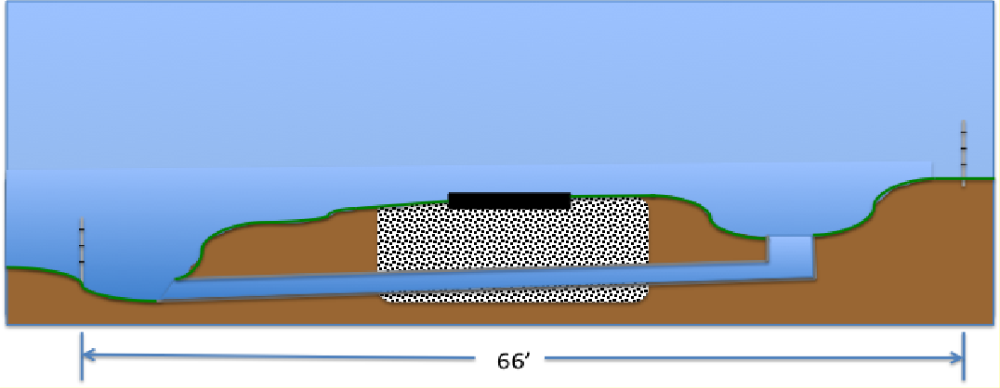
9’ Asphalt
West Boundary
East Boundary
Ditch & under-trail culverts
Gravel Bed
Typical cross section of the LMSP right-of-way Figure A-1

FLMSP has administratively separated the fifty miles of trail into four sections:

Designator | Nearby Towns | Roads and Mile Markers*
Far North | (northern terminus), Xenia, Spring Valley, Roxanna, New Burlington, Corwin | Hedges Rd to Middletown Rd,  Mile markers 3.3-16.8*
Mid-North | Corwin, Oregonia,  Ft. Ancient, Morrow | Middletown Rd. to Rt.123 / Mill St  Mile Markers 16.8-28.0
Mid-South | Morrow, South Lebanon, Grandin, Fosters, Loveland north | Rt.123 / Mill St. to Cones Road  Mile markers 28.0 – 41.0
Far South | Loveland south, Miamiville, Wards Corner, Camp Dennison, Milford, Terrace Park (south terminus) | Cones Rd. to Wooster Pike  Mile markers 41.0 – 53.5

*The historically based mile marker system starts at Xenia Railroad Station in Xenia located 3.3 miles from the start of the Little Miami State Park. As you progress southward, milage markers increase in value.

Each section has a section maintenance leader in charge of maintaining that section of the trail and who runs the work crews doing chainsaw and all other jobs as needed. In addition, FLMSP runs a Hotline where immediate trail maintenance needs can be reported by volunteers or the general public using the trail. Additionally, ODNR is in contact with FLMSP to request removal of downed trees, limbs that may impact mowing crews, impact horse riders, etc.

The following section describes the rules, regulations and standard operating procedures for the Chainsaw Team. This section is intended for the Chainsaw Team lead, members, and helpers as well as trail volunteers who have been certified for chainsaw use by the State Parks and wish to perform maintenance with a chain saw on their segment of trail.

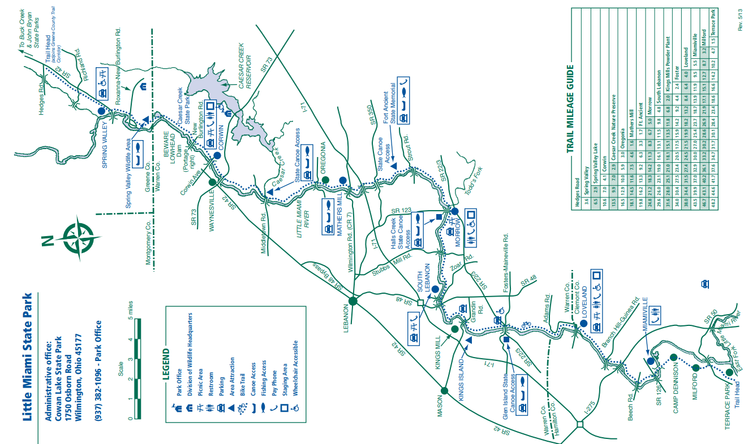

Figure A-2 Little Miami State Park

Map is available on-line on the FLMSP website

Authority
Chainsaw operators are part of the FLMSP crew program and as such received their authority through the Ohio State Park Individual Volunteer agreement and the FLMSP / ODNR Cooperative Agreement (with Addendum. The Agreement is of special importance for chainsaw operators and teams. The Right of Entry agreement gives permission for FLMSP volunteers to take vehicles onto the trail and dictates the rules that must be followed when working on the trail. The primary focus is the continued safety of the trail users while the trail maintenance activity is being carried out. Chainsaw operators must be in good standing with both organizations. Authority may be revoked due to negligence, operating equipment under the influence of drugs/alcohol, or not following rules mandated by either organization. ODNR has final authority over any chainsaw actions performed on the trail.

Chainsaw volunteers work under a section maintenance lead. Section leads must be informed of all work performed on their section of trail. The current section leads as of March 2025 are:

Far North | Dick Feldmann
Mid-North | Dick Feldmann
Mid-South | Rick Forrester
Far South | Bruce Cortright

QUALIFICATION OF CHAINSAW OPERATORS

The FLMSP has developed detailed safety rules for chain saw use and a Chainsaw Operators Qualification Program.

Individuals must be “qualified” before they can operate chainsaws in the Little Miami State Park. This is because ODNR and FLMSP are highly concerned with personnel safety. Ensuring the safety of the saw operator, the other FLMSP volunteers, and the park users is—by far—the biggest priority associated with any chainsaw activity. The qualification process assures that the volunteer meets a certain standard for knowledge and operating skills. It also decreases the risk of volunteers hurting themselves, coworkers, or trail users, as well as the risk of property damage.

Qualification Procedures: Only the Chainsaw Team Leader will assess the qualifications of applicants in order to ensure consistency of expectations. The team leader will keep records of who is qualified and submit the information to the VicNet database manager. The qualification is a one-time event as opposed to a periodic test. Any Friends member may seek qualification. This is not limited to segment adopters.

Qualification Criteria: The person seeking qualification must:
- Must be a current member in good standing of FLMSP. They must be physically capable of performing the work safely.
- Sign and renew (every two years) the volunteer agreements required by ODNR.
- Fill out and submit any requisite insurance forms to both organizations, if they will be driving their personal vehicle to get to the work area.
- Show basic knowledge of chainsaw operating procedures and FLMSP chainsaw safety rules as demonstrated by a passing grade on a written quiz and answer any questions the chainsaw team leader may have relating to operating chain saws in the Park.
- Demonstrate acceptable skills of servicing, starting, stopping, and cutting techniques by performing their chainsaw skills on the trail in situ, under observation by the Chainsaw Team Leader.

Training: Access and view the training sources below. They provide the operation and safety guidelines approved by ODNR and FLMSP. Studying them will enable the volunteer to pass the quiz section of the qualification procedure.
- Our FLMSP chainsaws are primarily made by Stihl which offers an excellent training video that can be found on YouTube:
http://www.youtube.com/watch?v=MUW7JNk7zVw
- The Stihl Chainsaw Safety Manual can be downloaded from: http://www.stihlusa.com/manuals/index.html
This document for chainsaw operators can also be viewed on the FLMSP website.

FLMSP chainsaw certified team leaders can also provide training to the volunteer prior to their seeking certification. This is an advisable but not mandatory step. Reach out to your team leader if interested.

CHAINSAW TEAM ACTIVITIES AND RESPONSIBILITIES
Once you have qualified for chainsaw operation as part of a FLMSP work crew, the following outlines the primary activities and responsibilities of the chainsaw teams. These are the SOPS followed by all our work crews on the trail.

Personnel: Chain sawing is not a single person activity. It is a Team activity. Any chainsaw work performed on the trail MUST have the saw operator and at least one other person to act as a safety. A third and/or fourth person is preferred so that trail traffic can be easily stopped in both directions as needed during operations. The operator, safety officer, and additional personnel must be members of FLMSP.

Hotline Response: Friends utilize an emergency “hotline” to report trees that have fallen across the trail (and any other emergencies). This hotline is often activated after severe weather. You may choose to have your phone number added to the Hotline calling tree, if you wish to be part of the “on-call” response team that deploys when trail clearing incidents arise. There is no requirement to be “on-call” and available – you will just be included in the list of folks notified when volunteers are needed. Being on the hotline emergency response team is encouraged but not mandatory.

Tasks (more or less, in order of priority):
Keep the trail clear / usable. Remove new treefalls blocking the trail within two days – IF: the team has (A) the skills to remove them safely and (B) the time and weather are amenable to address the treefall safely. If (A) or (B) can’t be met, inform the State Park and trail section leaders regarding the situation.

Keep the existing berms clear Remove old treefalls, trunks, branches and other wood debris that require chainsaw cuts in order to remove. This work is important but not urgent. The timeline will be managed by the trail section maintenance leads and the chain saw teams (and their crews).

Removal includes relocating the wood to the side of the trail, but within the park boundary, minimizing visual impact to park users.
Note concerning vegetation removal: It is unlawful to take firewood and timber from an Ohio State Park. For most chainsaw activities, push natural debris and vegetation off the berm or to an out-of-the- way location on site to decompose naturally. The river side of the trail is preferred as it will help stabilize the riverbank. In situations such as after a storm where there is an excessive amount of material and removal from the area is recommended, FLMSP may contact the Park Manager for removal of the wood to another park or may request a written waiver such that individuals can legally remove cut logs from the park.

Limitation on live tree removal: Chainsaw Teams will remove trees that are already down or leaning significantly and present an immediate danger to trail users. If the need arises to remove a still standing upright tree, or if a downed tree is above the head, only a park maintenance staff member may remove these trees (limitation imposed by both ODNR and FLMSP insurance underwriter)..

Maintain the chainsaws: Chainsaw operators will perform basic maintenance on the chainsaws before, during, and after use. Maintenance supplies are supplied by FLMSP with no expense to the operators. Operators will ensure the saws are returned as good as or better than when they started the work session. In the event of a needed repair, Repair Tags are available to be attached to the saw or saw blade listing the issue, date, and volunteer’s name. The volunteer should contact the section leader or chainsaw team leader to address the issue.

The majority of saws used by FLMSP are high compression Stihl gas 2-cycle powered saws. They use mid-grade (92) octane fuel mixed with Stihl Ultra fuel oil additive in the ratio indicated in the owner’s manual for the saw (usually 50:1 ratio). Fuel safety cans and bar oil are located in the tool caches. Alcohol free gas is not required.

Saws will have a full servicing at least once a year. This entails: replacing the spark plug, air filter, gas filter, oil filter, and chain bar (if needed). Adjust the throttle, service the carburetor and clean the entire unit.

Tool Boxes:
FLMSP maintains tool boxes for the chainsaws that include the following items:

- Round file and/or Stihl 2in1 Tool. The file diameters are specific to the make/model of chain used
- Flat file for fine tuning the chain depth gauge (raker)
- Black marker for marking chain
- Shop towel
- Spark plug
- Spare chains
- Carburetor adjustment screwdriver
- Wrench to remove chain retainer nuts and cover screws
- Repair tags
- Toothbrush to remove dirt/debris

Maintain a record of volunteer service hours: Volunteers are to record their hours worked on the trail in the FLMSP database (currently using the VicNet app).

SAFETY
The following apply to FLMSP volunteers who are chainsaw qualified. All other FLMSP volunteer personnel are NOT permitted to use chainsaws in the course of their volunteer work.

Personal Protective Equipment (PPE):
The following Personal Protective Equipment (PPE) must be worn at all times during chainsaw operation:

Supplied by FLMSP (available in tool caches for use by volunteers):

- High visibility hard-hat
- Safety glasses with safety shields or a face screen
- Hearing protection
- Chainsaw safety chaps
- Safety vest (for assistants, not chainsaw operators as they may present a hazard)

Supplied by Volunteer:

- Sturdy pants and shirt. No loose fit clothing that might become saw-entangled
- Safety glasses with safety shields or a face screen

- Non-slip work gloves (preferably leather)
- Sturdy footwear with non-slip soles

Safety Procedures:
The procedures below are generally considered good/best practice during trail maintenance, but unlikely to cover every circumstance that a volunteer may encounter. There is no substitute for good judgment regarding what actions can be performed safely. DO NOT take on any job or even a single cut which you cannot perform safely. Remember this statistic: 95% of the injuries involving chainsaws are preventable!

General:
- Based on the work to be done and potential hazards, the volunteer may temporarily close the affected trail section or let trail users proceed with caution. In either case, signs must be placed on the trail per the ODNR Right of Entry agreement advising trail users of the trail status and volunteer activity.
- DO NOT work when you are fatigued. Be aware of becoming dehydrated or over-heated.
- NEVER WORK ALONE! A minimum of two people must be present as stated previously. The chainsaw operator must be within verbal range of their assistant and the safety watch must have a working cell phone for summoning emergency help.
Prior to starting the cutting work, the chainsaw operator and safety watch must discuss their injury response plan:
  - Identify the vehicle to be driven to the hospital/ urgent care and where the keys are.
  - Identify your location (i.e. mile marker and nearest cross roads) on the trail.
  - Identify the nearest Urgent Care facility.
  - Identify the person(s) with cell phone(s) who will place the emergency call.
  - Identify the location of the first aid kit.

- Have a first aid kit on site. Trauma first aid kits are stored with the chain saws. These kits must be on site when any chain saw work is performed. Contact the team leader if you do not have first aid training.
Be aware of the possibility of bees, hornets, ground-dwelling yellow jackets, poison ivy and other biological hazards.
- Tuck in drawstrings that are on hooded jackets or long hair that dangles down. Remove rings and jewelry. Remove objects from pockets that might fall out while cutting.
- Inspect the saw before use. Ensure both that the inertial and manual activators of the chain brake are in proper working condition. Inspect the chain catch for damage and have it repaired as necessary. Also, test the throttle lock-out feature for proper operation. Inspect the bar and chain and repair or replace as necessary. While wearing gloves, work the chain back and forth on the bar to test for proper tensioning and correct installation.
- Safe Starting: Do not drop-start the chainsaw. A chain saw is safest to start on the ground with the chain brake engaged. Be sure nothing is obstructing the guide bar/chain. To make sure the saw sits securely on the ground, place your right foot in the rear handles. The saw may be started using the between-the-legs starting method only if trained to do so.
- Carefully “size up” each cut. Anticipate how the wood will move/react to your cut. If you’re unsure of the wood’s reaction, make shallow cuts pausing to watch the piece react and identify the direction it wants to go.
- Don’t let anyone hold the log or limb being cut. Work at a safe distance from others.
- ALWAYS maintain control by standing securely holding the saw firmly and taking your hand off the trigger between cuts.
- NEVER straddle the log to make a cut.
- Whenever you are cutting, be sure your body is clear of the natural path which the saw will follow when the cut goes through.
- ALWAYS shut off the engine before setting the chain saw down—even when you are retreating from a falling tree
- The chain saw must be shut down or the chain break activated whenever the saw is carried more than a few steps. Whenever possible use the bar cover. A saw should be carried by its front handle with the chain bar pointing to the rear. Do not carry the chain saw on your shoulder.
- Cut with the underside of the saw blade closest to the housing—not with the tip or nose.
- The saws are designed to be run at full throttle. Maintain a high saw speed when entering, cutting and leaving the wood cut.
- To avoid pinching, rotate limb or log to be cut or insert a short log under the cut area. If the saw becomes pinched, shut it off and insert a log under it to eliminate the pinching. A wedge may also be used.
- Keep the chain sharp. The chainsaw supplies included in the tool kits have appropriate sharpening tools, and training videos are readily available on the web. Periodically, blades are also professionally sharpened by third party vendors – but frequent sharpening by volunteers keeps the saw in best operational condition in-between servicing. A SHARP BLADE IS A SAFE BLADE!
- DO NOT cut above mid-chest height; the saw would be too close to your face.
- DO NOT cut brush or shrubbery with a chainsaw unless necessary. It can throw the chain off the blade. There are other tools in the cache supplies better suited for that purpose!

Refueling and fire hazards:
- NEVER fuel a saw while the engine is running.
- NEVER fuel a hot saw.
- NEVER smoke or have any type of flame while you are around a saw or during fueling.
- NEVER start the saw where you fueled the engine. Move at least 10 feet away.
- Keep leaves and dry materials away from the hot muffler.
- It is advisable to give the chain a quick sharpening at every refueling.

Limbing:
- Stand on the opposite side of the tree whenever possible, using it as a barrier between yourself and the limb you are cutting. Do not overstretch yourself to do this because it would make you less stable.
- Do not face the limb you are cutting squarely—stand at a 45-degree angle to prevent the saw from striking your leg if it slips.
- If you are on a hill, stand on the upside of the hill.
- NEVER cut limbs above mid-chest height. Use a pole saw if appropriate.
- Do not cut limbs that are supporting the log.

Reducing the Risk of Kickback: Kickback occurs when a force causes the bar to “kick” up and back towards the operator and may result in a loss of control and possible injury. There are several causes:
  - an abrupt change in wood character—hitting a knot or a nail or barbed wire
  - cutting with the upper tip of the bar
  - striking a nearby limb with the tip of the moving chain while cutting
  - running the chain too slowly
  - twisting the saw in your cut so the chain grabs
  - using a dull or loose chain
  - having a loose grip on the saw or cutting with only one hand
  - not paying attention
Remember:
- Never cut with the upper half of the tip of the bar
- Always hold the saw firmly with both hands and keep the left arm as straight and stable as possible
- Use a saw equipped with a chain brake, anti-kickback chain, or other anti-kickback devices.

Volunteer Limitations/Prohibitions:
FLMSP chainsaw-certified volunteers must obey the following prohibitions:
- Chainsaw teams are limited to cutting only in Little Miami State Park property, or on adjacent ODNR property (if permission is granted).
- Do not work from a ladder or from within a tree.
- Do not do boring cuts unless absolutely necessary. This technique may be risky unless you are trained for the job.
- Do not remove live trees without ODNR permission.
- Do not remove standing dead trees without ODNR permission
- Do not remove wood from the State Park unless permission is granted by ODNR.
- Never work alone.
- All personal protective equipment must be worn while performing chainsaw work.

Available Equipment:
FLMSP has a variety of tools, including gas-powered brush cutters, chainsaws, leaf blowers, asphalt/concrete grinder, mini-excavator, and a brush mower. We also have hand tools such as loppers (long- handled pruners), rakes, shovels, axes, and mattocks. Safety vests, gloves, glasses, and earplugs are available as well.

Tool caches that have chainsaw equipment:

Far North | Roxanna New Burlington Road in Spring Valley
Mid-North | South Lebanon (Hopkinsville) Public Storage, Rt. 22&3
Mid-South | Fosters, old railroad post office building, Old 3C Highway
Far South | Ernst Concrete storage barn on Glendale Milford Rd
.

Emergency Information

Emergency Information:
FLMSP chainsaw volunteers are to be aware of the exact location when traveling and working on the trail. They must know the nearest mile marker, the nearest cross street, and whether they are north or south of that cross street. Exact location information, nature of the emergency, steps being taken by responders, contact phone number, etc. are required when contacting public safety departments (Fire, EMS, and Rescue), ODNR park rangers, and FLMSP leadership.

First aid kits are supplied to each crew and volunteers should be familiar with their use. It is highly encouraged that volunteers take a basic first aid course, CPR/AED (automated external defibrillator), and other emergency courses from the American Red Cross, local community colleges, or other organizations.

For immediate fire department response (serious chainsaw injuries, heat stroke, heart attack, rescue, etc.), dial 911.

Little Miami / Caesar Creek Park Rangers may be contacted via text at #ODNR

The park manager (currently Tiffany DeChant-Hunt) may be contacted at:

Office (513) 897-3055, or by cell (614-314-3714)
Tiffany.DeChant-Hunt@dnr.ohio.gov

Park Maintenance Lead (Currently Casey Marcum) may be contacted at:

ODNR Cell: 937-475-3840
Casey.Marcum@dnr.ohio.gov

The FLMSP trail Hotline number is (513) 212-6958

The president of FLMSP may be contacted at: president@flmsp.org

Additional contact information:

Hamilton County Sheriff 513-825-2280
Clermont County Sheriff 513-732-7500
Warren County Sheriff 513-695-1280
Green County Sheriff 937-825-1500

Hamilton Township Police 513-683-0583

DOCUMENT AUTHORS AND VERSION CONTROL

Version | Changes | Author
1.00 | Initial | Dick Feldmann
2.00 | Not recorded | Aaron Rourke
3.10 March 21, 2025 | Full Revision, updated all names/addresses/contact info, updated multiple rules for using saws, added park map, updated tool cache info, updated database procedures, removed references to Adopt-A-Trail, updated Cooperative Agreement and Right of Entry info, formatting | Rick Forrester

